EduPath: A Career Guidance
Website for Undergraduates

Abstract

The usefulness of Edupath, a website that offers career advice to undergraduate students, is investigated in this research study. The purpose of the study is to evaluate how Edupath affects undergraduate users' overall happiness, academic performance, and career decision-making process. Employing a mixed-methods approach, information was gathered via surveys, interviews, and use analytics to examine students' perspectives and experiences with Edupath. According to the results, Edupath is crucial in helping undergraduate students choose their career routes by offering them useful tools, advice, and assistance. Overall, this study advances knowledge on the beneficial effects that online resources such as Edupath may have on students' career development, emphasising the value of easily available and customised career counselling resources in higher education.

- Introduction

In today's educational environment, [2] a student's move from high school to a university or the job is a momentous occasion that is full with chances and challenges. [3] At this point, choosing future job paths requires critical thought and informed decision-making, which calls for easily accessible and trustworthy guidance tools. In this environment, EduPath stands out as a leader by providing a thorough platform that helps recent high school graduates navigate the plethora of trendy and available post-12th standard employment alternatives (as shown in figure 1). EduPath seeks to equip [7] students with the knowledge and resources they need to make decisions that align with their unique interests, abilities, and goals by combining in-depth research on a variety of professional paths with cutting-edge technological solutions.


EduPath's aim is centered on [1] democratizing career advising access so that all students can explore and pursue rewarding career options, regardless of their background or circumstances. Through the use of its user-friendly features and intuitive layout, EduPath offers students a smooth and seamless way to explore a wide range of career alternatives, from established professions to emergent industries propelled by technological breakthroughs. Furthermore, EduPath's [4] dynamic platform is always developing to meet the demands of the market and industry trends, giving students up-to-date knowledge of the always shifting job market.
Figure 1: Helps students to choose not any career, choose the best career.

EduPath operates on the principle that every individual deserves equal opportunities to discover and pursue their passions. [9] By leveraging technology and innovative solutions, EduPath strives to break down barriers to career guidance, providing accessible resources and personalized support to empower students in their journey towards fulfilling careers. Through partnerships with educational institutions, community organizations, and industry experts, EduPath ensures that its platform remains inclusive and relevant, catering to the diverse needs and aspirations of learners from all walks of life.

Furthermore, EduPath is committed to [5] fostering a supportive and nurturing environment where students can not only explore their career interests but also develop the skills and confidence needed to succeed in today's competitive job market. Beyond offering career guidance, EduPath equips students with practical tools, such as resume-building tips, interview preparation resources, and networking opportunities, to help them navigate their professional endeavors with resilience and determination. [10] By instilling a growth mindset and promoting lifelong learning, EduPath endeavors to empower individuals to realize their full potential and thrive in their chosen career paths, thereby contributing positively to society and the global workforce.

II. Literature Survey

(Dhananjaya et al, 2017) [1] This study examines the career maturity of adolescents in private and government schools, aiming to bridge the gap between education and career choices. 200 high school students from Haldwani were randomly selected, 100 from each type of school. Socio-demographic data was collected, and Career Maturity was assessed using the Career Maturity Inventory Indian adaptation. Statistical analysis revealed significant differences in career maturity between the two settings, with private school students exhibiting higher maturity levels across all assessed components. Variances were attributed to factors such as gender composition, family type, number of siblings, and ordinal position.

(Kumar S et al, 2019) [2] This paper delves into the vital issue of career guidance within the context of economically developing countries, drawing attention from both the theoretical and practical realms of the career community. It begins by outlining the framework proposed by the International Labour Organization (ILO) for crafting career guidance systems in low- and middle-income nations.

(Palade et al, 2019) [3] The pursuit of professional career development is seen as a dual-purpose endeavor, serving both the aspirations of employees and the strategic objectives of organizations, departing from traditional approaches focused solely on institutional needs. The overarching goal of career development is to cultivate individual professionalism and personal well-being, while concurrently fostering organizational prosperity. Central to effective career management is the practice of career planning and development, intricately linked with human resources planning.

(Bishnoi M et al, 2018) [4] A review of previous literature suggests that a negatively-significant relationship exists between career decision-making difficulties and college self-efficacy within students, but studies inspecting the association of these factors with future anxiety and the new-normal life have been scarce. Present study therefore aims to investigate the Career Decision-Making Difficulties, College Self-Efficacy, Fear of Covid-19 and Future Anxiety among College and University Students.

(DeLese MA et al, 2020) [5] This review delves into using e-learning technology and personalized recommendation systems in education. It examines 60 articles from prominent databases and identifies the different methods used in recommendation systems, such as collaborative and content-based approaches with a recent shift towards machine learning. However, the current personalized recommendation system faces challenges such as a lack of understanding of the content, student discontinuity, language barriers, confusion in selecting study materials, and inadequate infrastructure and funding. The review proposes using new digital technologies to address these issues, including Fluxy AI, Twin technology, AI-powered virtual proctoring, and Alter Ego.

(Dhillon U et al, 2020) [6] This study aims to compare high-school students in Turkey and the U.S., in terms of career-decision making difficulties. The research group consists of a total of 576 students, including 296 high-school students in the U.S, and 280 high-school students in Turkey. The data of the research were collected by the “Career Decision-Making Difficulties Questionnaire” (CDDQ). The career decision-making difficulties are composed of three sub-scales, including lack of readiness, lack of information and inconsistent information. Multivariate Analysis of Variance (MANOVA) was used to evaluate whether the sub-scale scores for career decision-making difficulties experienced by high-school students in the U.S. and Turkey differ depending on an individual’s gender and class.

(Gupta N et al, 2021) [7] The COVID-19 pandemic, coupled with the advent of AI-based technologies, has led to widespread job losses across sectors worldwide, with a significant portion being permanent. Additionally, the true extent of unemployment may be higher than reported, and the proliferation of AI tools like Generative Pretrained Transformers (GPT) is expected to exacerbate this trend. Business operations are likely to face prolonged disruptions and underperformance, necessitating the development of robust recovery strategies. A key component of such strategies is the rapid re-education of the workforce to meet evolving market demands. With intelligent and virtual workplaces poised to replace traditional office setups, many low-skilled jobs are at risk of permanent displacement. This paper proposes an AI-driven framework, named Career-gAIde, aimed at swiftly re-educating workers to adapt to changing market dynamics and mitigate the impact of job loss in evolving sectors.

(Letha NC et al, 2021) [8] Ensuring student satisfaction with their courses is crucial for universities to thrive in a competitive landscape. This research introduces a career-focused educational model, Map My Career, designed to enhance student satisfaction by addressing key areas such as academic preparedness, workload management, skill development, and graduate employability. Implemented as a software application, Map My Career utilizes text mining and data analytics to assist students in selecting and managing subjects relevant to their desired careers. By analyzing data from educational settings and job advertisements, the application connects courses, skills, and careers, identifying any disparities between market demands and curriculum offerings.

(Ottu IFA et al,2021) [9] Choosing a university specialization poses a significant challenge for high school students, often leading to decisions based on subjective factors such as familial influence and limited online resources. This tendency heightens the risk of high dropout rates and frequent changes in disciplines. To mitigate these challenges, this research paper introduces a Personalized Career-path Recommender System (PCRS) tailored to assist high school students in selecting an engineering discipline. The design of PCRS leverages fuzzy intelligence within an N-layered architecture, utilizing students' academic performance, personality traits, and extracurricular skills.

(Gideon Arulmani et al, 2021) [10] This study investigates the impact of a career decision-making program on high school students' difficulties in making career decisions. Employing a placebo control group with pretest, posttest, and follow-up test design, participants were randomly selected from two high schools in Turkey, totaling 400 students. The experimental group comprised 15 students (8 female, 7 male), while the placebo control group included 15 students (7 female, 8 male). Career decision-making difficulties were assessed using the Career Decision-making Difficulties Questionnaire (CDDQ), adapted for Turkish adolescents.
III. Methodology:

A methodical approach is necessary to produce an efficient state chart that will lead students through the EduPath website's job choosing procedure. Determining every state a pupil may experience along the way is the first step. Start (first time on the website), Introduction (welcome message and navigation guide), Assessment (personality and skill assessments), Career Matches (list of possible careers), Career Profiles (detailed career information), Educational Pathways (course and college recommendations), Decision-Making (career comparison), Action Plan (goal setting and step-by-step plan), Community and Support (participation in forums and expert advice), Progress Tracking (monitoring progress and receiving updates), and End (process completion or exit) are some of these states.

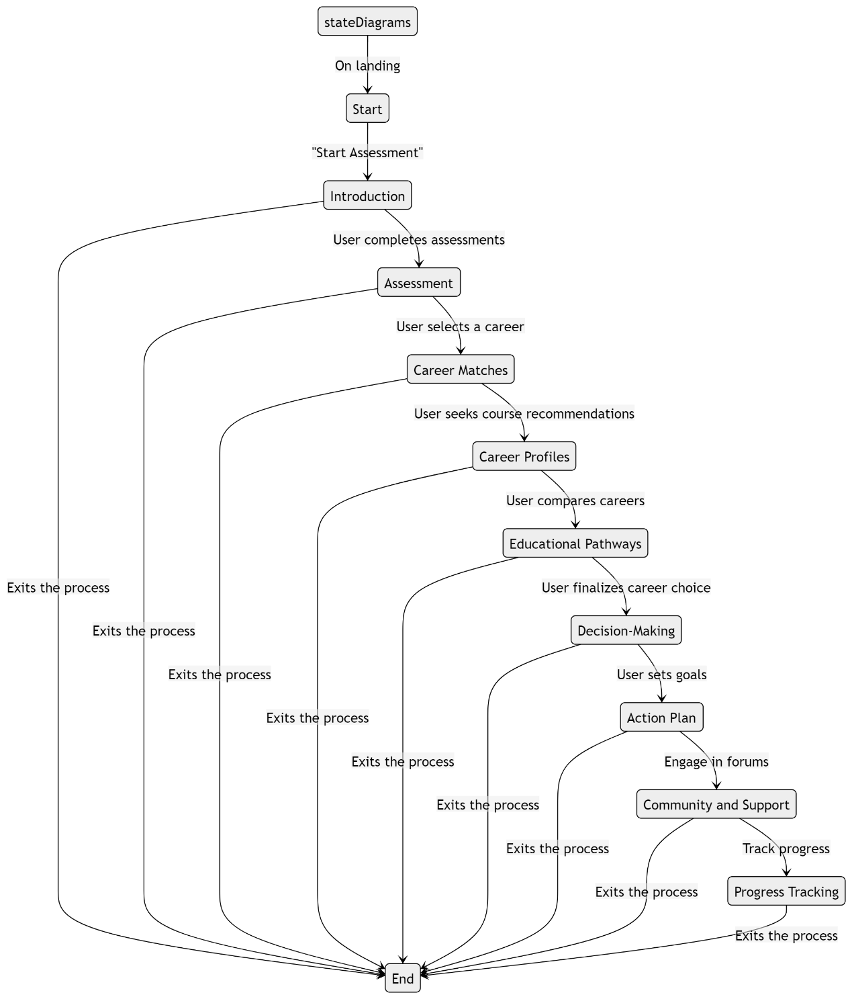

Figure 2: State Chart Diagram for EduPath
Once the user gets on the page, there is a transition from Start to Introduction; similarly, clicking "Start Assessment" takes them from Introduction to Assessment. Students move to Career Matches, where they see a list of possible jobs, after finishing the exams. They go to job Profiles after choosing a job to investigate, and Educational Pathways are where they go after looking for course recommendations. After comparing jobs in the Decision-Making stage, students make their ultimate career decision and establish objectives in the Action Plan stage. In the Community and Support state, they may participate in forums or ask for help; in the Progress Tracking state, they can monitor their progress; and finally, when they finish or leave, they can reach the End state.

IV. Results:

The Edupath career advising website was built with HTML, CSS, JavaScript, and Bootstrap to provide a responsive and user-friendly design. Encryption ensures that user credentials and information are protected, and the backend is driven by a strong database management system to handle user data and interactions securely. Agile development methods were used throughout, including iterative design, testing, and feedback cycles to improve the platform. A secure login and registration process that enables users to build personal profiles, extensive career assessment tools that evaluate user interests, abilities, and personality traits using psychometric tests and questionnaires, and a customized career recommendation system based on these findings are some of Edupath's standout features.

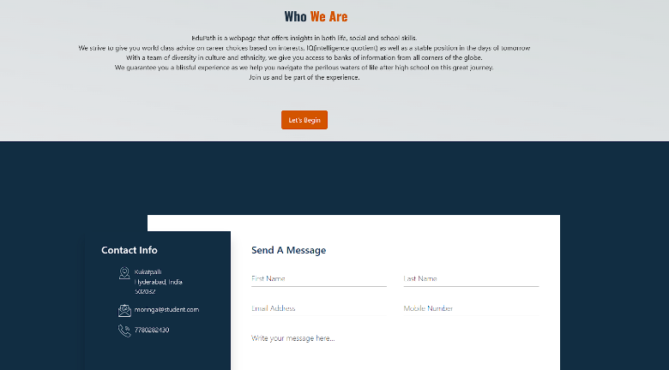

The website also features a large and often updated collection of resources that offers details on a range of career options, necessary qualifications, employment trends, and educational institutions. With simple navigation between parts like career exams, resource sites, and virtual mentoring programmes, the user experience is designed to be straightforward. The platform's success and user happiness are demonstrated by the high engagement rates, as indicated by analytics. Users spend an average of 15 minutes each session and regularly visit the career evaluation and resource areas. The development team placed significant emphasis on user experience (UX) design to ensure that the website is both engaging and easy to navigate which helps user by increasing the friendliness of the website (As shown in figure 3 and figure 4). By doing this user can easily interact with the website which can further increase their understandings.
Figure 4: Index page of EduPath Website
Figure 3: Index page of EduPath Website

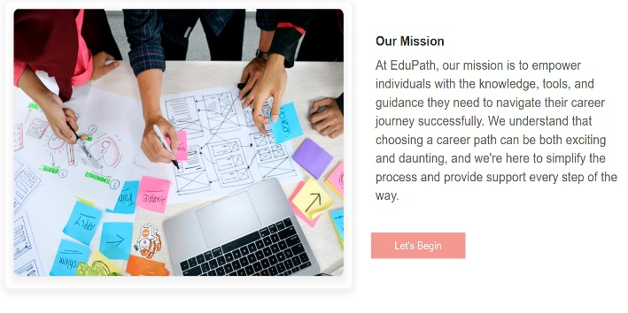
The UI was refined with great care regarding user experience, and features like a dashboard that gives users rapid access to their personalised suggestions, recent searches, and bookmarked sites were included(as shown in figure 1 and figure 7). An algorithm that links user inputs with possible career paths—providing comprehensive descriptions, necessary credentials, and possible career trajectories—is integrated with the career evaluation tools. By offering material specific to their individual profiles, this personalised approach not only assists consumers in making their engagement.
Figure 5: About us page of EduPath Website

Furthermore, the website's functionality is supported by a responsive design that ensures compatibility across various devices, including desktops, tablets, and smartphones (as shown in figure 7, figure 8). This multi-device option
Figure 6: Login page of EduPath Website
is essential as it enables convenient, remote platform access for users. Additionally, Edupath includes interactive features like forums and discussion boards where users may communicate with peers and mentors, exchange experiences, and pose questions. The entire user experience has been improved by the supportive atmosphere that has been created by these community features.

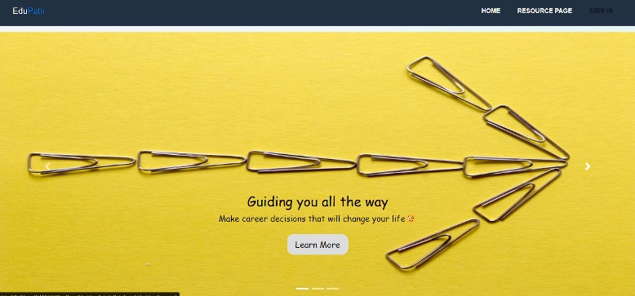

Figure 7: Career guidance page of EduPath Website

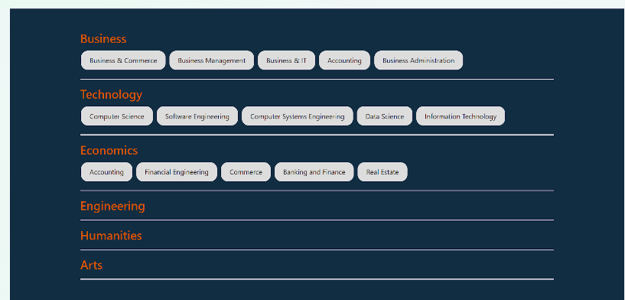

Figure 8: Carrer options page of EduPath Website

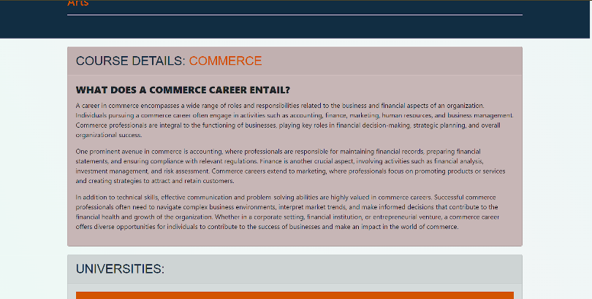

Figure 9: About career page of EduPath Website

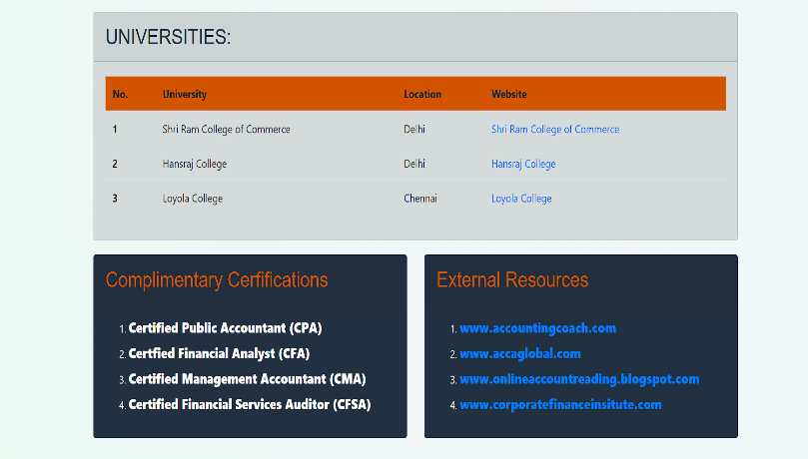

Figure 10: Career guide page of EduPath website

V. Conclusion:

The EduPath website is a feature-rich educational platform that caters to a wide range of learning requirements. It offers personalised learning routes, engaging course materials, and robust support networks like mentoring and tutoring. Wide people can visit the site because of its easy-to-use layout and smooth navigation, which improve the entire learning experience. The platform is notable for its dedication to accessibility and diversity; in addition to providing resources for students with impairments, it offers bilingual support to reach a worldwide audience. Its real-time feedback systems and utilisation of multimedia information guarantee that learning is both effective and entertaining.

In conclusion, EduPath skilfully makes use of technology to deliver excellent, easily accessible education. The platform's strengths are found in its extensive course selection, easy-to-use layout, and dedication to diversity. Still, there's always space for development and enhancement. EduPath may reach a larger audience by adding more vocational and technical areas to its course catalogue. Learners will receive the most up-to-date and pertinent knowledge if the content is updated on a regular basis to be in line with the most recent standards and trends in education. Additionally, improving community elements like peer support groups, interactive forums, and cooperative projects can result in a more stimulating and encouraging learning environment. With these further improvements, EduPath has the ability to completely transform education and assist students of all backgrounds in achieving their academic and career objectives.
References:

- Dhananjaya. G. M., et al., "Career Decision Making Difficulties Comparison," Proc. International Journal of Home Science 2017; 3(1): 242-245.

- Kumar S, "Career Services in Developing Countries: Importance and Framework," Proc. Indian Journal of Career and Livelihood Planning

- Journal of the Indian Association for Career and Livelihood Planning (IACLP)ISSN 2319-2313Volume 2, Issue 1, December 2019.

- Palade, "Achievements and Research Focus," Proc. European Institute for Risk Security and Communication Management, 82-84 Eminescu Street, Bucharest, Romania.

- Bishnoi M, kumar M. Study of Career Maturity in Relation to Level of Aspiration in Adolescents. Darpan International Research Analysis. 2018; 1(8).

- DeLese MA. Identification and analysis of the factors influencing students’ preference in career vocational training choice. Thesis, Ph.D. Temple University. 218; 69(1):195-A,2020.

- Dhillon U, Kaur R. Career Maturity of School Children. Journal of the Indian Academy of Applied Psychology. 2020; 31(1-2):71-76.

- Gupta N. Indian Adaptation of Crites Career Maturity Inventory (CMI). National Psychological Corporation, Agra, 2021.

- Letha NC, Amin N. Career Aspirations and Adolescents in the Indian Context. Scholarly Research Journal for Inter disciplinary Studies. 2021; 1(2).

- Ottu IFA, Idowu OO. Openness to Experience, Conscientiousness and Gender as Personality Indicators of Career Maturity of In-School Adolescents in Ibadan, Nigeria. European Journal of Educational Studies. 2020; 6(1).

- Gideon Arulmani, Sonali Nag-Arulmani, Work Orientations and Responses to Career Choices – Indian Regional Survey (WORCC-IRS), National Consultation on Career Psychology (NCCP) 6 th and 7th January 2016 Whitefield, Bangalore, India

